OUR VALUES

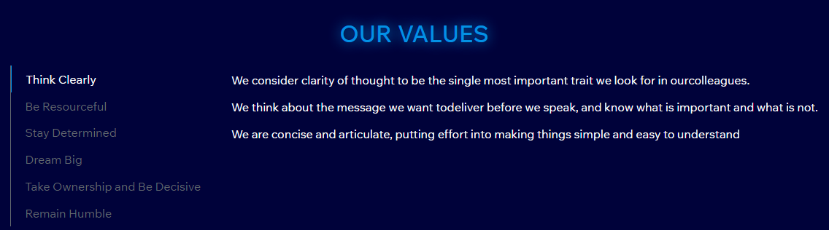

1. **Think Clearly**

1. The SpoticCoin team demonstrates a strong consensus-building approach through active listening and open communication.

2. Each team member is encouraged to bring their unique perspective and expertise to contribute towards achieving the team's goals.

3. They promote a collaborative and inclusive environment where all team members are empowered to contribute equally and feel valued for their contributions.

4. Their team thinking is characterized by well-defined roles and responsibilities, clear objectives, and effective problem-solving strategies.

1. **Be Resourceful**

1. SpoticCoin's team is responsible for delivering high-quality products and services to customers.

2. The team is responsible for adhering to the company's core values and mission statement.

3. They are responsible for maintaining healthy work relationships and effective communication within the team.

4. The team is also responsible for constantly improving their skills and knowledge to ensure the company's success and growth.

1. **Stay Determined**

1. Despite the challenges that have come their way, the company's team remains steadfastly determined to achieve its goals.

2. They understand that determination is the key to success and have continued to push themselves beyond their limits.

3. The team has a strong work ethic and never shies away from any task, no matter how challenging it may be.

4. Every member of the team supports and motivates one another, fostering a culture of resilience and determination to achieve great things.

1. **Dream Big**

1. SpoticCoin team members are highly motivated individuals who passionately believe in dreaming big.

2. They constantly strive to achieve their goals and push their limits beyond what others may deem possible.

3. Collaborating with one another, they take calculated risks and boldly pursue new ventures, recognizing that the rewards can be immense.

4. The team's collective vision and determination are what sets them apart, inspiring them to achieve unparalleled success and continuously reach new heights.

1. **Take Ownership and Be Decisive**

1. SpoticCoin team has taken ownership of their respective responsibilities and are making informed decisions.

2. With a sense of ownership and autonomy, the team is actively seeking out opportunities to take charge and lead.

3. The team's decisive actions have led to improved efficiencies, clear communication, and enhanced productivity.

4. Taking ownership and being decisive has instilled a sense of confidence and trust in the company's team, paving the way for growth and success.

1. **Remain Humble**

1. SpoticCoin team has taken ownership of their respective responsibilities and are making informed decisions.

2. With a sense of ownership and autonomy, the team is actively seeking out opportunities to take charge and lead.

3. The team's decisive actions have led to improved efficiencies, clear communication, and enhanced productivity.

4. Taking ownership and being decisive has instilled a sense of confidence and trust in the company's team, paving the way for growth and success.